
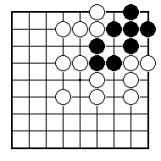
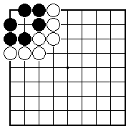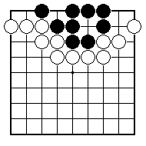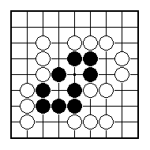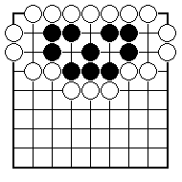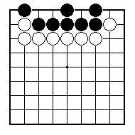
Has the black group got two real eyes?

Has the black group got two real eyes?

Has the black group got two real eyes?

How can White stop Black from making two real eyes?

How can Black make sure that the black group has two real eyes?

How can White stop the black group making two real eyes?

NAME:
BRITISH GO ASSOCIATION CERTIFICATE LEVEL 1 - SHEET 9

REAL EYES AND FALSE EYES

